|  |  |  |  |  |  |  |  |  |
| --- | --- | --- | --- | --- | --- | --- | --- | --- |
| Forecast Values | |  |  |  | Compiler Engine Information | | |  |
|  |  |  |  |  |  |  |  |  |
| Stand ID: | | 888936 | | | GYPSY Model: | | 2009-May-21 | |
| Stand Type: | | Natural |  |  | Application: | | 20100713p | |
| Stand Age: | | 50 | years |  | COM DLL: | | 20100329b35 | |
| Spatial: | | NO |  |  |  |  |  |  |
| BA adjusted: | | YES |  |  |  |  |  |  |
|  |  |  |  |  |  |  |  |  |
| Input Data | |  |  |  |  |  |  |  |
|  |  |  |  |  |  |  |  |  |
| Species | | totage | topht | den | ps | ba | utilization | |
| AW |  | 50.0 | 8.57 | 1162 |  | 10.42 | 13/7/30 | |
| SB |  |  |  |  |  |  | 15/10/30 | |
| SW |  | 49.0 | 8.57 | 399 |  | 3.58 | 13/7/30 | |
| PL |  | 39.0 | 8.57 | 254 |  | 2.27 | 13/7/30 | |
|  |  |  |  |  |  |  |  |  |
| Calculated Attributes | | |  |  |  |  |  |  |
|  |  |  |  |  |  |  |  |  |
| Species | | bhage | y2bh | si_bh | si_t | n0 | sdf | psi |
| AW |  | 42.6 | 7.4 | 9.6 | 8.6 | 2,194 | 999 |  |
| SB |  |  |  |  |  |  |  |  |
| SW |  | 36.7 | 12.3 | 11.0 | 8.8 | 417 | 398 |  |
| PL |  | 29.6 | 9.4 | 12.3 | 10.7 | 254 | 253 |  |

Tesera Gypsy

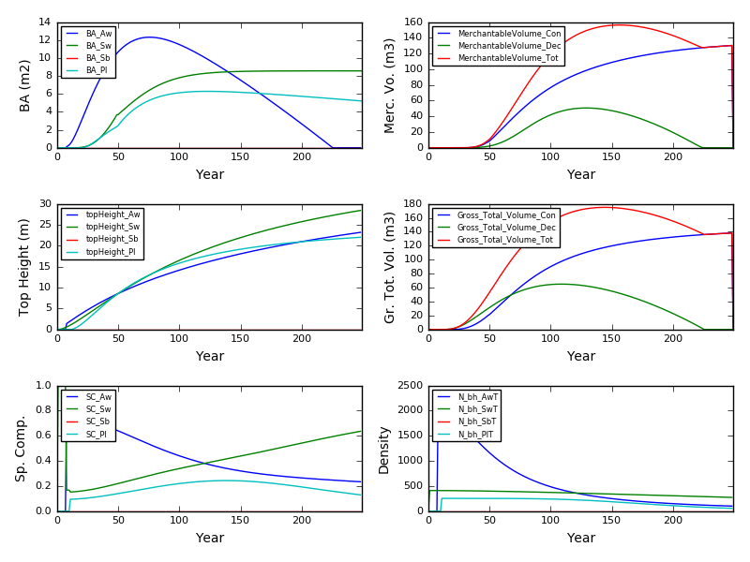

Excel Gypsy

